P250/1

**GEOGRAPHY**

**(PHYSICAL GEOGRAPHY)**

PAPER 1

JULY/AUGUST 2016

3HRS

WESTERN JOINT MOCK EXAMINATIONS

Uganda Advanced Certificate of Education

**GEOGRAPHY**

**(PHYSICAL GEOGRAPHY)**

**PAPER 1**

3HOURS

**INSTRUCTIONS TO CANDIDATES:**

* This paper consists of three sections A, B and C
* Answer four questions
* Section A is compulsory.
* Answer one question from section B and one Question from Section C
* Credit will be given for use of relevant sketch maps, diagrams and specific examples studied in the field
* Any additional Question(s) attempted will not be marked.

**SECTION A**

**Question 1 and 2 are compulsory.**

**COMPULSORY MAPWORK QUESTION.**

1. Study the map extract 1:50,000 (UGANDA) MPARA part of sheet, 67/2 Y732, edition 1-U.S.D 1 and Answer the questions that follow:

(a) (i) State the grid reference of the secondary trigonometrical station at Rwahunga. **01mk**

(ii) Identify the drainage feature found at grid reference 720530 **01mk**

(b) Draw a reduced sketch map of the area using factor 2 and on the map, mark and name: **08mks**

(i) Papyrus swamp

(ii) Any 2 rivers

(iii) Buhungiro forest reserve

(iv) Dry weather roads

(c) Calculate the

(i) New scale of the reduced sketch map. **02mks**

(ii) Vertical interval of the map extract. **01mk**

(d) Describe the relief of the area **06mks**

(e) Describe the relationship between relief and land use. **06mks**

**COMPULSORY PHOTOGRAPH INTERPRETATION QUESTION**

2. Study the photograph provided below and answer the questions that follow:

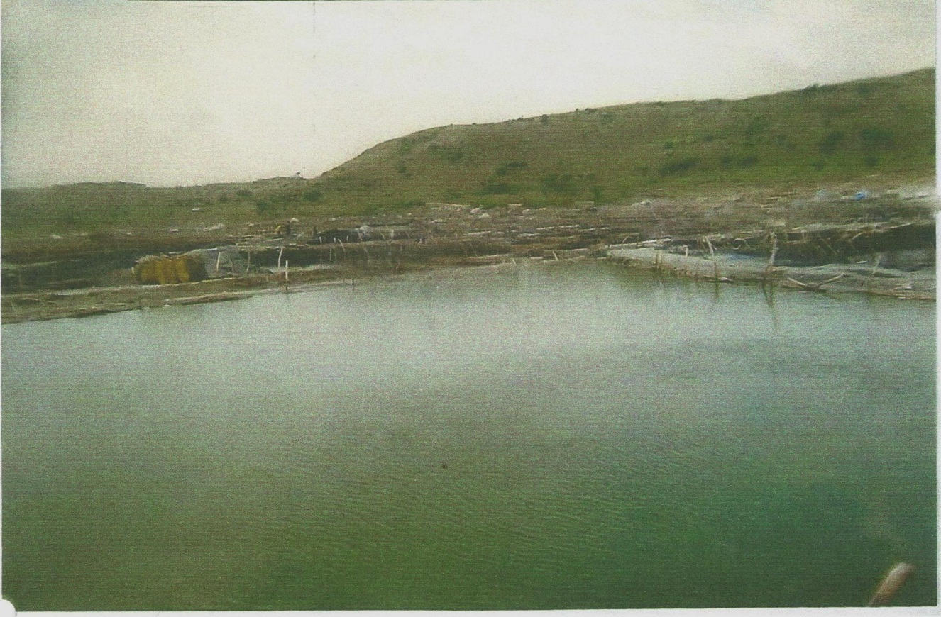

(a) Draw a landscape sketch of the photograph and on it mark and name; **08mks**

(i) Physiographic regions

(ii) Vegetation types

(iii) Salt pan

(iv) Salt lake

(b) Describe the process of extraction of the salt seen in the photograph **06mks**

(c) Describe the factors which have favoured salt extraction in the area **06mks**

(d) (i) Describe the effects of salt extraction in the area shown in the photograph **03mks**

(ii) Giving evidence, suggest an area where the photograph could have been taken **02mks**

**SECTION B**

**Answer one question from this section**

3. Asses the relevance of wegner’s theory of continental drift in explaining the present day positions of continents. **25mks**

4. Examine the influence of earth movements on landform formation in East African. **25mks**

5. Examine the causes of a rise in sea level and the resultant landforms in East Africa. **25mks**

**SECTION C**

**Answer one question from this section**

6. Examine the processes responsible for the formation of the following:

(a) Relief rainfall **09mks**

(b) Frontal rainfall **09mks**

(c) Hail **07mks**

7. Assess the influence of altitude on vegetation distribution in East Africa **25mks**

8. (a) What is meant by the term Soil profile? **10mks**

(b) Examine the processes responsible for development of a soil profile. **15mks**

**END**